Keyboard with tactile feedback on smartphone touch screen

vibration haptic feedback keyboard

【Summary】：

The paper developed a numeric keypad that can provide tactile feedback through short-term vibration of the phone.

【Method】:

Crossing the boundary of the key 5 causes a short vibration, which is useful for entering or exiting the key with a finger. We call this vibration boundary feedback. For example, sliding a finger from key 8 to key 5 from bottom to top will generate a short vibration when crossing the lower boundary of key 5, and then continue to slide toward key 2, and the same feedback will be provided again when the boundary is crossed. The left and right buttons 4-5-6 on the horizontal line and the horizontal line sliding from top to bottom also apply.

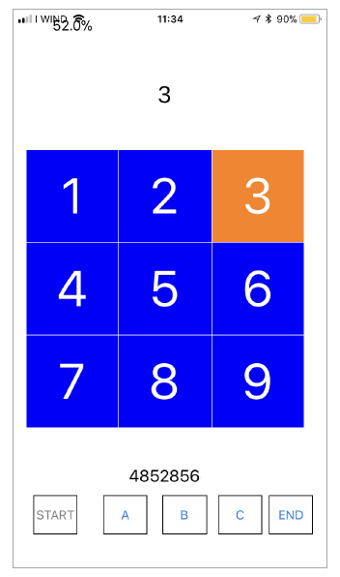

【Conclusion】：

We described the design and implementation of a haptic keyboard on iPhone7 which provides tactile feedbacks when crossing the borders of key 5 and when inputting any digit. We ran a test with 34 users, not described here, that showed how tactile feedback can help finding the position of keys and inputting numbers without looking at the smartphone screen. In the conference demo users will test the interface as above, and discuss their experiences.

【Subjective analysis】：

**Advantage:**

A virtual numeric keyboard based on iphone's vibration feedback is designed to give different feedback when swiping through different keys, and then click the required key to complete the input. In this process, the user is provided with edge feedback and key feedback.

**Disadvantages:**

Just experiment on the numeric keypad. Unable to verify, if you can get good results on a keyboard with more keys.

**Next:**

Apply to QWERTY keyboard or nine-key typing.

【Important Reference】:

[2] Stephen Brewster and Lorna M. Brown. 2004. Tactons: Structured Tactile Mes-sages for Non-visual Information Display. In Proceedings of the Fifth Conference on Australasian User Interface - Volume 28 (AUIC ’04). Australian Computer Society, Inc., Darlinghurst, Australia, Australia, 15–23. http://dl.acm.org/citation.cfm?id= 976310.976313

[6] Seung-Chan Kim, Ali Israr, and Ivan Poupyrev. 2013. Tactile Rendering of 3D Features on Touch Surfaces. In Proceedings of the 26th Annual ACM Symposium on User Interface Software and Technology (UIST ’13). ACM, New York, NY, USA, 531–538. https://doi.org/10.1145/2501988.2502020

[7] Emilia Koskinen, Topi Kaaresoja, and Pauli Laitinen. 2008. Feel-good Touch: Finding the Most Pleasant Tactile Feedback for a Mobile Touch Screen Button. In Proceedings of the 10th International Conference on Multimodal Interfaces (ICMI ’08). ACM, New York, NY, USA, 297–304. https://doi.org/10.1145/1452392.1452453

[8] Pauli Laitinen and Jani Mawnpaa. 2006. Enabling mobile haptic design: Piezo-electric actuator technology properties in hand held devices. In Haptic Audio Visual Environments and their Applications, 2006. HAVE 2006. IEEE International Workshop on. IEEE, 40–43.

[9] Rock Leung, Karon MacLean, Martin Bue Bertelsen, and Mayukh Saubhasik. 2007. Evaluation of Haptically Augmented Touchscreen Gui Elements Under Cognitive Load. In Proceedings of the 9th International Conference on Multimodal Interfaces (ICMI ’07). ACM, New York, NY, USA, 374–381. https://doi.org/10.1145/1322192. 1322258

[10] Andrew Nashel and Sharif Razzaque. 2003. Tactile Virtual Buttons for Mobile Devices. In CHI ’03 Extended Abstracts on Human Factors in Computing Systems (CHI EA ’03). ACM, New York, NY, USA, 854–855. https://doi.org/10.1145/765891. 766032

[11] Toni Pakkanen, Roope Raisamo, Katri Salminen, and Veikko Surakka. 2010. Haptic Numbers: Three Haptic Representation Models for Numbers on a Touch Screen Phone. In International Conference on Multimodal Interfaces and the Workshop on Machine Learning for Multimodal Interaction (ICMI-MLMI ’10). ACM, New York, NY, USA, Article 35, 4 pages. https://doi.org/10.1145/1891903.1891949

[12] Koji Yatani and Khai Nhut Truong. 2009. SemFeel: A User Interface with Semantic Tactile Feedback for Mobile Touch-screen Devices. In Proceedings of the 22Nd Annual ACM Symposium on User Interface Software and Technology (UIST ’09). ACM, New York, NY, USA, 111–120. https://doi.org/10.1145/1622176.1622198